Silver oak collage of computer application

Name: Dishang .A. khalashi

No.2204030101908

1. HTML Headings:

* heading Used for show in html
* #h1 to #h6 tags are supported the global attribute in html.
* Search engines use the headings to index the structure and content of your web pages.
* Users often skim a page by its headings. It is important to use headings to show the document structure.
* <h1> headings should be used for main headings, followed by <h2> headings, then the less important <h3>, and so on.
* Html heading tags H1,H2,H3,H4,H5,H6

1. Italic Tag:

* The <i> tag defines a part of text in an alternate voice or mood. The content inside is typically displayed in italic.
* The <i> tag is often used to indicate a technical term, a phrase from another language, a thought, a ship name, etc.
* Use the <i> element only when there is not a more appropriate semantic element
* Syntax: <i>italic</i>

1. Emphasized tag:

* The <em> tag is used to define emphasized text. The content inside is typically displayed in italic.
* A screen reader will pronounce the words in <em> with an emphasis, using verbal stress.
* Syntax:<em>emphasized</em>

1. Citration Tag:

* Text enclosed in <cite> tags is intended to represent the title of a work (e.g. a book, a paper, an essay, a poem, a score, a song, a script, a film, a TV show, a game, a sculpture, a painting, a theatre production, a play, an opera, a musical, an exhibition, etc).
* Syntax

The <cite> tag is written as <cite></cite> with the citation inserted between the start and end tags.

I

1. Insertion tag:

* The <ins> tag defines a text that has been inserted into a document. Browsers will usually underline inserted text.

Syntax:<p>my favourite car is <del>Ferrari

H2</del><ins>

Gixxy</ins>!</p>

1. Delete tag:

The <del> tag defines text that has been deleted from a document. Browsers will usually strike a line through deleted text.

Syntax: :- p>my favourite bike is<del>ninja h2</del><ins>

1. **SPAN/DIV:-**

* The <span> tag is much like the <div> element,but<div>

Tag is a block level element and <span> is an inline

Element.

1. **PARAGRAPH:-**

* The paragraph define a paragraph

:-<p>this is some text in paragraph</p>

1. **BLOCKQUOTE:-**

* The <blockquote> tag specifies a section that is quoted from another source.

**10. SUPERSCRIPT TAG:-**

* the <sup> tag define superdcript text,used for Formula

**11**. **SUBSCRIPT** **TAG**:-

* THE <sub> tag define subscript text,used for

Chemistry formula h20

**12.ABBR:-**

* The <abbr> tag define an abbreviation or an acronym.

**13. &NBSP:-**

* A commonly used entity in html is the non-breaking space

**14.BOLD,STRONG:-**The html <b> element define bold text. The <strong> tag define text with strong importance.

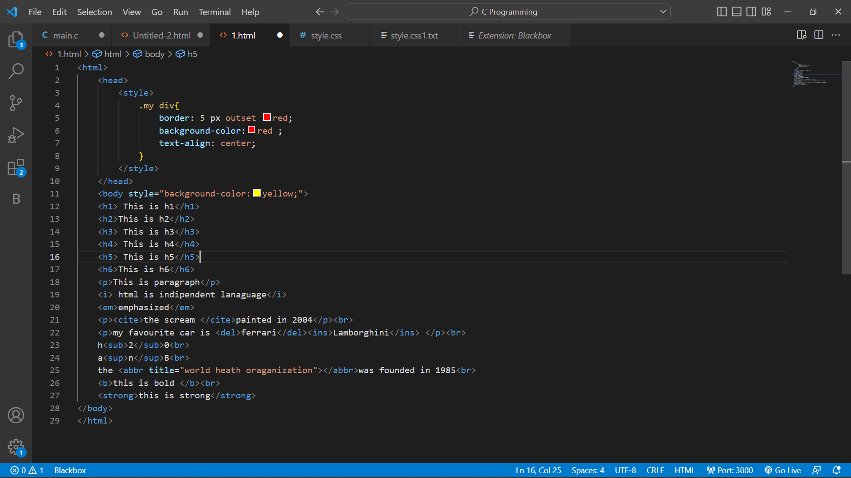

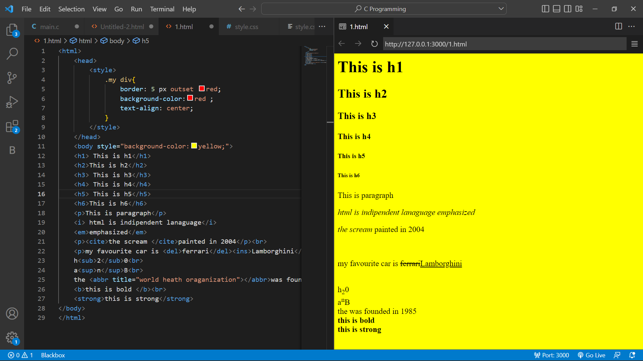s